GSP 270 Project
Abstract:
Sea level rise is a potentially catastrophic and worldwide phenomenon that can be measured and for the most part predicted. We decided to create three representation maps of sea level rise at rising increments of 10 meters for Los Angeles, San Luis Obispo, and San Diego county in the state of California, all of which will be affected. For this study, we will discuss why we chose to study the problem at hand, the methods by which we examined the effects of rising sea level on three important counties. We will then show the results of this phenomenon on these three counties and the results of this study. Then we will discuss the implications of this study and anything we might have overlooked.
Introduction:
Among the many problems of the upcoming century is the threat of rising sea levels, a phenomenon brought about by the melting of glaciers from climatic temperatures higher than temperatures of the pre-industrial age. This phenomenon has the potential to bring widespread destruction to coastal areas including major cities that lie along it. Most of humanity lives within proximity to a coastline and are at some degree of risk from rising tides. There is thought to be an overall rate of just less than 2 mm rise per year. The impacts of sea level rise include coastal inundation and erosion, higher waves, and salt water intrusion among other effects (Church: 2008) To prepare for these possible outcomes, we must analyze possible effects in sites around the world. For our final assignment this semester, the three of us examined the rise of sea level in counties in California: Andie for San Diego County, Jacob for San Luis Obispo County, and Marcel for Los Angeles County. All are major counties within the state whose impact by rising sea levels has the potential to impact us all. Having analyzed the rise of sea level in these areas, we will now share the methods by which we performed our analysis and the results of this study.
Methods:
We performed our analysis using ArcMap 10.2.2, a program that allows one to create maps and do spatial analysis. Individually, we started off with digital elevation models of our respective counties, which show the elevation of an area. We then created a locator map to show where said chosen counties can be found in the state of California.
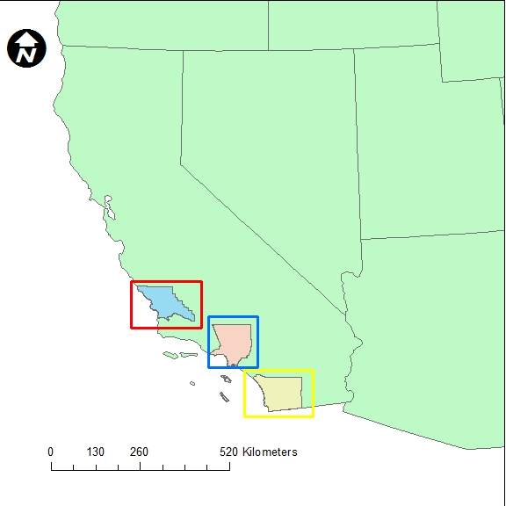
Figure 1: locator map of San Luis Obispo county with red square, Los Angeles County with blue square, and San Diego county with yellow square
Then we created various models showing the rise of sea level onto land. We did this through use of the raster calculator in which we started off with the equation
DEM<=0 meters.
This created a raster with a 0 meter sea level rise. As in, one which showed sea level at its natural elevation. We then created the same equation but solved for areas less than or equal to 10 meters. Through this, we made a raster which contains 0’s where the equation proved false and 1’s where the equation proved true. In other words, the color next to 0 in the legend referred to areas that were not affected by a 10 meter sea level rise whereas the color next to 1 in the legend referred to areas that were impacted by a 10 meter sea level rise. We also used this equation in the raster calculator 10 meter sea level rise-Sea level rise. This created a raster showing areas above 0 meters and below 10 meters. This helped us to calculate the area of these rasters which would be impacted by sea level rise. For that, we solved for area of hectares,
$$Area in m^{2}=\#Pixels*(\frac{80.35m^{2}}{1 Pixel})$$
From there, we converted area in meters squared to area in hectares.
$$Area in Hectares=Area in{ m}^{2}*(\frac{1 hectare}{10,000 m^{2}})$$
We swapped the area in meters squared for the number of pixels since we found it easier to work with.
$$Area in Hectares=\#Pixels*\left(\frac{80.35m^{2}}{1 Pixel}\right)*(\frac{1 hectare}{10,000{ m}^{2}})$$
From there, we could finally solve for hectares,
$$Area in hectares=\#Pixels*0.008035$$
We repeated these processes for areas impacted by a 20, 30, 40, 50, and 60 meter sea level rise as well. Once all the necessary information was found, we added it onto maps with a legend showing the areas hit by sea level rise at certain meters.
Results:
Listed here are the results of our study examining the effects of sea level rise on our respective counties. On each map we have recorded a legend showing where the water reaches based on the distance it rises. Areas marked by a mild blue color are impacted by sea level rise to 10 meters while dark blue areas signify 20 meters. Dark red areas will be impacted if the sea level rises to 30 meters and orange if it rises to 40 meters. Finally, 50 meter impacted areas are marked by a yellowish-orange color and 60 meters by a bright yellow. It should be noted that the areas in color that are on the east side of San Diego County will not be affected by sea level rise because they are inland. The colors just represent that they are at sea level, and if were next to the ocean, would have been. We also included a table showing how much area of land would be covered in hectares per rise in sea level.
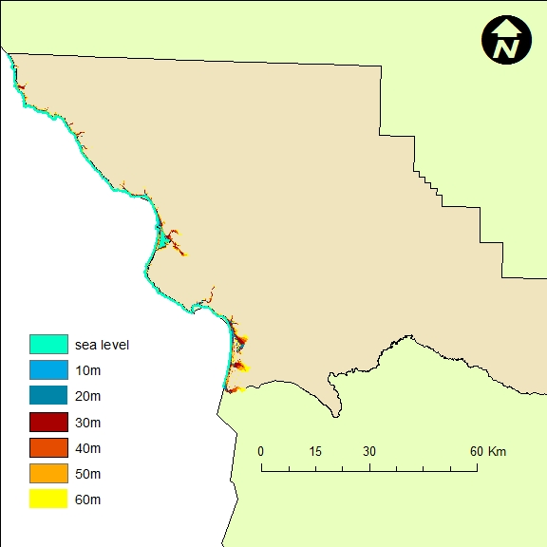
Figure 2: San Luis Obispo County, showing sea level rise at increasing increments of 10 meters

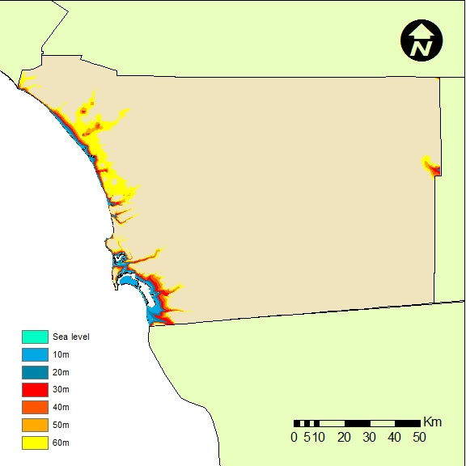
Figure 3: San Diego County, showing sea level rise at increasing increments of 10 meters

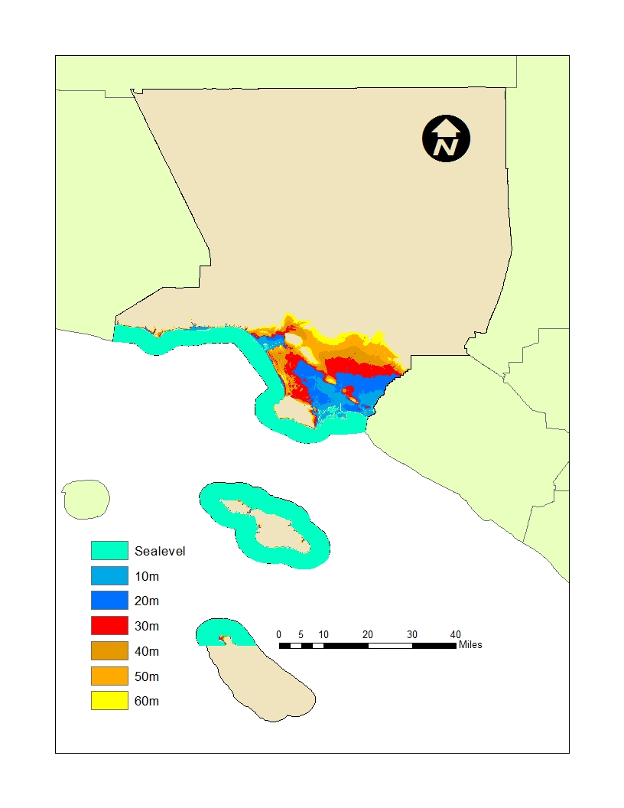Figure 4. Los Angeles County, showing sea level rise at increasing increments of 10 meters

Area of sea level inundation measured in Hectares
Area Covered by Sea Level Rise | Los Angeles County | San Diego County | San Luis Obispo County
10 meters | 15071 | 7948.68 | 7050.15
20 meters | 17257.31 | 13767.02 | 19179.54
30 meters | 19468.66 | 20511.19 | 42755.31
40 meters | 21336.26 | 27389.59 | 62092.17
50 meters | 23145.46 | 35641.78 | 85250.88
60 meters | 24386.60 | 66676.31 | 105013.08

Table 1. Sea Level Inundation Area Calculated for the Three Counties

Discussion/Conclusion:
We have discussed the means by which we determined the rise of sea level and its effects on certain counties within the state of California. Sea level rise has far reaching and global implications. Almost all coastal communities will be detrimentally affected by sea level rise, displacing millions of people globally and destroying millions of acres of already inhabited land. There are steps that the global community can take as a whole, drastically lowering our carbon emissions to reduce global warming therefore slowing and potentially stopping the increase in ice melt at the poles, but with the way things are going so far, it’s just a matter of time until the inevitable happens. This catastrophic sea level rise won’t be during our own personal lifetimes, but there are steps we can personally take to help fight this worldwide threat to our livelihoods. We understand that these representations of sea level rise alone will be insufficient towards preparing for all effects of global sea level rise. However, we know that it is just another step in understanding this important phenomenon and ultimately combating the effects that will occur should it transpire.

References:
Church, John, et al. "Sea-level rise." Transitions: Pathways Towards Sustainable Urban Development in Australia, CSIRO Publishing, Melbourne(2008): 191-210.
Rahmstorf, Stefan. "A semi-empirical approach to projecting future sea-level rise." Science 315.5810 (2007): 368-370.

